EX.NO: 7 IMPLEMENTATION OF RSA

AIM
To implement the RSA encryption and decryption algorithm using Python.

ALGORITHM
- Select two prime numbers p and q.
- Compute n = p × q.
- Compute φ(n) = (p − 1)(q − 1).
- Choose e such that gcd(e, φ(n)) = 1.
- Compute d such that (d × e) mod φ(n) = 1.
- Encrypt the message using C = M^e mod n.
- Decrypt the ciphertext using M = C^d mod n.
- Display the encrypted and decrypted messages.

PYTHON CODE
p = 11
q = 13

n = p * q
e = 7
d = 103

msg = input("Enter Message: ")

cipher = [pow(ord(ch), e, n) for ch in msg]
print("Encrypted:", cipher)

plain = "".join(chr(pow(c, d, n)) for c in cipher)
print("Decrypted:", plain)

SAMPLE OUTPUT
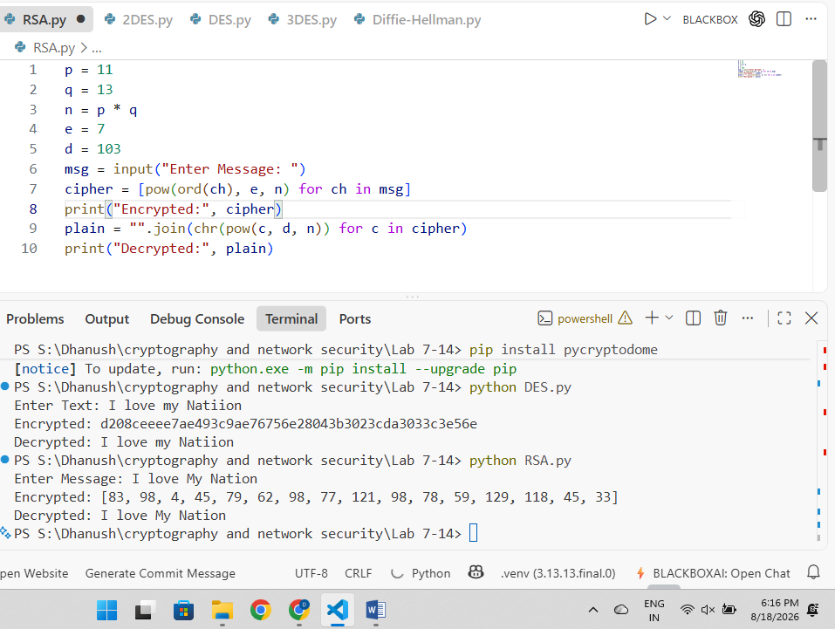

RESULT
Hence the output is verified successfully and RSA algorithm is verified.

EX.NO: 2 – IMPLEMENTATION OF DES MODES (ECB)

AIM
To implement DES encryption and decryption using ECB mode in Python.

ALGORITHM
- Read plaintext and key.
- Create DES cipher in ECB mode.
- Encrypt plaintext.
- Display ciphertext.
- Decrypt ciphertext.
- Display original text.

PYTHON PROGRAM
from Crypto.Cipher import DES
from Crypto.Util.Padding import pad, unpad

key = b"12345678"

text = input("Enter Text: ")

cipher = DES.new(key, DES.MODE_ECB)

encrypted = cipher.encrypt(pad(text.encode(), 8))
print("Encrypted:", encrypted.hex())

decrypted = unpad(cipher.decrypt(encrypted), 8)
print("Decrypted:", decrypted.decode())

SAMPLE OUTPUT

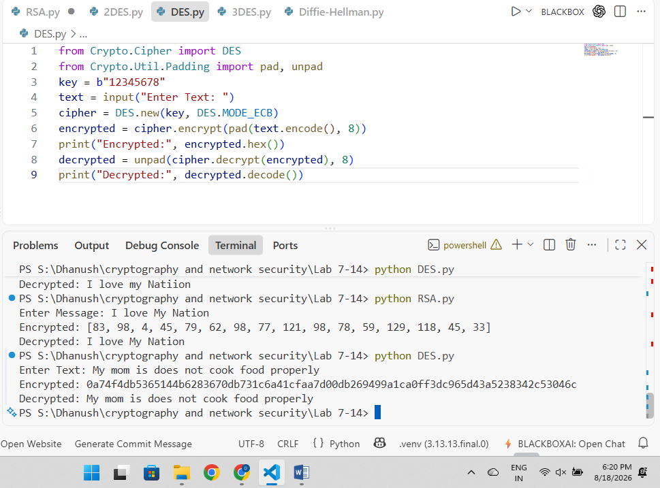

RESULT
Thus, DES ECB mode was implemented successfully.

EX.NO: 3 – IMPLEMENTATION OF DES MODES (CBC)

AIM
To implement DES encryption and decryption using CBC mode.

ALGORITHM
- Read plaintext.
- Create DES cipher using CBC mode.
- Encrypt plaintext.
- Display ciphertext.
- Decrypt ciphertext.
- Display original text.

PYTHON PROGRAM
from Crypto.Cipher import DES
from Crypto.Util.Padding import pad, unpad

key = b"12345678"
iv = b"abcdefgh"

text = input("Enter Text: ")

cipher = DES.new(key, DES.MODE_CBC, iv)
encrypted = cipher.encrypt(pad(text.encode(), 8))

print("Encrypted:", encrypted.hex())

cipher = DES.new(key, DES.MODE_CBC, iv)
decrypted = unpad(cipher.decrypt(encrypted), 8)

print("Decrypted:", decrypted.decode())

SAMPLE OUTPUT

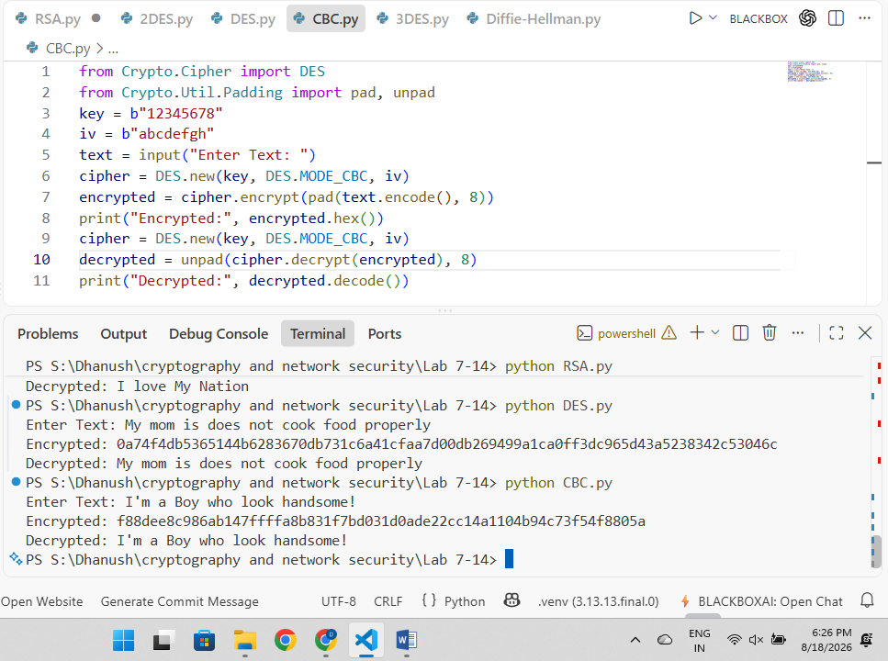

RESULT
Thus, DES CBC mode was implemented successfully.

EX.NO: 4 IMPLEMENTATION OF DES MODES (CFB)

AIM
To implement DES encryption and decryption using CFB mode.

ALGORITHM
- Read plaintext.
- Create DES cipher using CFB mode.
- Encrypt plaintext.
- Decrypt ciphertext.
- Display result.

PYTHON PROGRAM
from Crypto.Cipher import DES

key = b"12345678"
iv = b"abcdefgh"

text = input("Enter Text: ")

cipher = DES.new(key, DES.MODE_CFB, iv)

encrypted = cipher.encrypt(text.encode())
print("Encrypted:", encrypted.hex())

cipher = DES.new(key, DES.MODE_CFB, iv)

decrypted = cipher.decrypt(encrypted)
print("Decrypted:", decrypted.decode())

SAMPLE OUTPUT
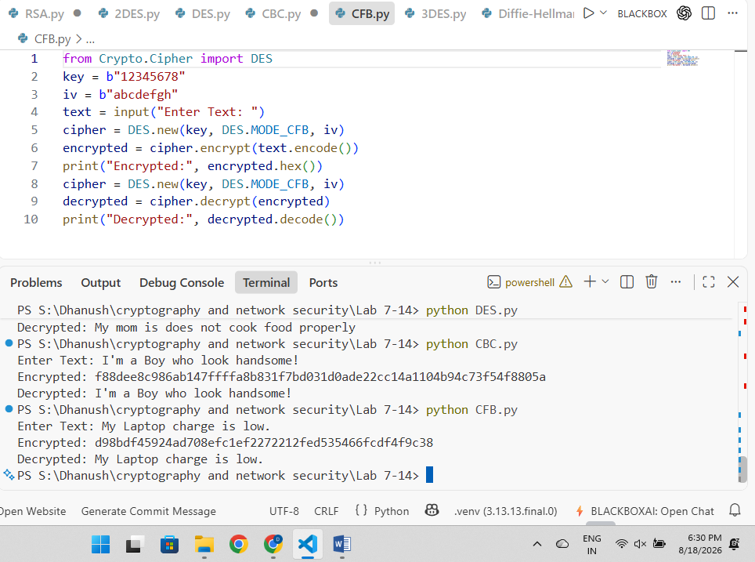

RESULT
Thus, DES CFB mode was implemented successfully.

EX.NO: 5 – IMPLEMENTATION OF DES MODES (OFB)

AIM
To implement DES encryption and decryption using OFB mode.

ALGORITHM
- Read plaintext.
- Create DES cipher using OFB mode.
- Encrypt plaintext.
- Decrypt ciphertext.
- Display result.

PYTHON PROGRAM
from Crypto.Cipher import DES

key = b"12345678"
iv = b"abcdefgh"

text = input("Enter Text: ")

cipher = DES.new(key, DES.MODE_OFB, iv)

encrypted = cipher.encrypt(text.encode())
print("Encrypted:", encrypted.hex())

cipher = DES.new(key, DES.MODE_OFB, iv)

decrypted = cipher.decrypt(encrypted)
print("Decrypted:", decrypted.decode())

SAMPLE OUTPUT

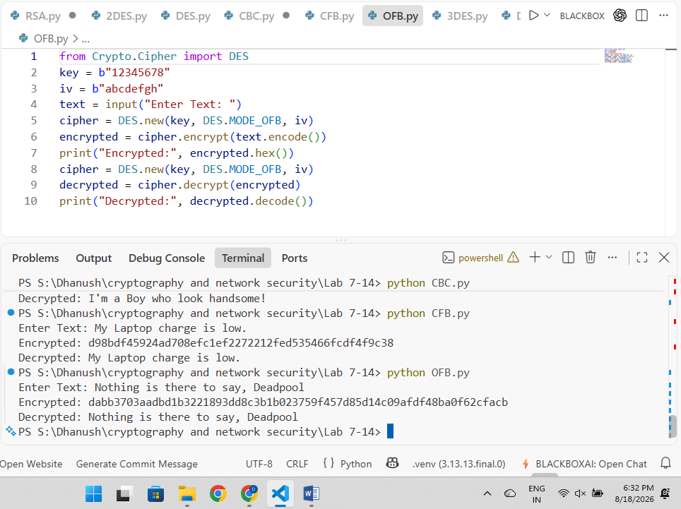

RESULT
Thus, DES OFB mode was implemented successfully.

EX.NO: 6 – IMPLEMENTATION OF 3DES

AIM
To implement 3DES encryption and decryption using three keys.

ALGORITHM
- Read plaintext.
- Encrypt using Key1.
- Encrypt using Key2.
- Encrypt using Key3.
- Display ciphertext.
- Decrypt in reverse order.
- Display plaintext.

PYTHON PROGRAM
text = input("Enter Text: ")

k1 = "key12345"
k2 = "pass6789"
k3 = "abc12345"

encrypted = ""

for i in range(len(text)):
c = ord(text[i]) ^ ord(k1[i % 8])
c ^= ord(k2[i % 8])
c ^= ord(k3[i % 8])
encrypted += chr(c)

print("Encrypted:", encrypted)

decrypted = ""

for i in range(len(encrypted)):
c = ord(encrypted[i]) ^ ord(k3[i % 8])
c ^= ord(k2[i % 8])
c ^= ord(k1[i % 8])
decrypted += chr(c)

print("Decrypted:", decrypted)

SAMPLE OUTPUT

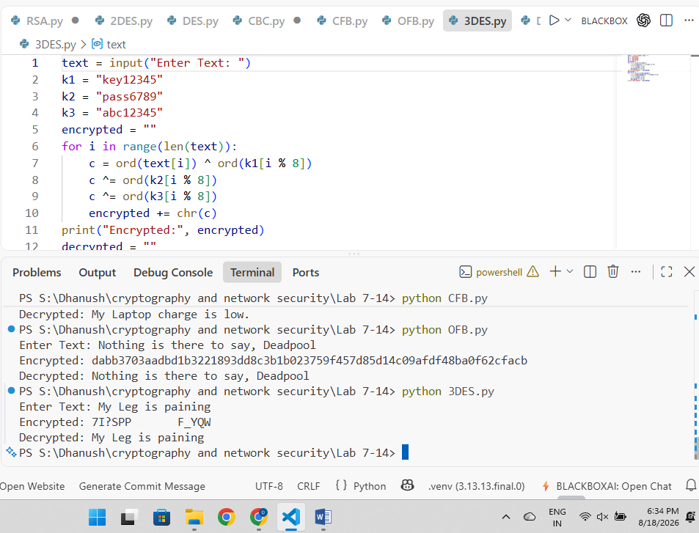

RESULT
Thus, the 3DES encryption and decryption process was implemented successfully.

EX.NO: 7 – IMPLEMENTATION OF 2DES

AIM
To implement 2DES encryption and decryption using two keys.

ALGORITHM
- Read plaintext.
- Encrypt using Key1.
- Encrypt using Key2.
- Display ciphertext.
- Decrypt using Key2 and Key1.
- Display plaintext.

PYTHON PROGRAM
text = input("Enter Text: ")

k1 = "key12345"
k2 = "pass6789"

encrypted = ""

for i in range(len(text)):
c = ord(text[i]) ^ ord(k1[i % 8])
c ^= ord(k2[i % 8])
encrypted += chr(c)

print("Encrypted:", encrypted)

decrypted = ""

for i in range(len(encrypted)):
c = ord(encrypted[i]) ^ ord(k2[i % 8])
c ^= ord(k1[i % 8])
decrypted += chr(c)

print("Decrypted:", decrypted)

SAMPLE OUTPUT

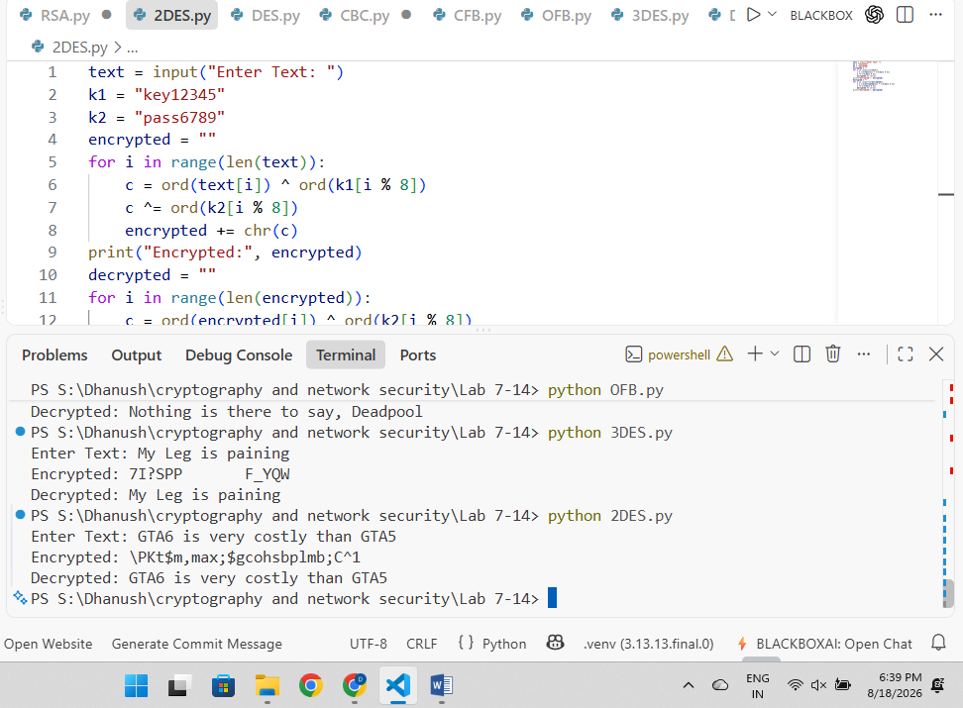

RESULT
Thus, the 2DES encryption and decryption process was implemented successfully.

EX.NO: 8 – IMPLEMENTATION OF ECC (ECDH)

AIM
To implement Elliptic Curve Cryptography (ECC) using ECDH to generate a shared secret key.

ALGORITHM
- Generate ECC key pair for User A.
- Generate ECC key pair for User B.
- Exchange public keys.
- Generate shared secret.
- Compare both secrets.
- Display result.

PYTHON PROGRAM
from cryptography.hazmat.primitives.asymmetric import ec

private1 = ec.generate_private_key(ec.SECP256R1())
private2 = ec.generate_private_key(ec.SECP256R1())

secret1 = private1.exchange(ec.ECDH(), private2.public_key())
secret2 = private2.exchange(ec.ECDH(), private1.public_key())

print("Shared Secret Match:", secret1 == secret2)

SAMPLE OUTPUT

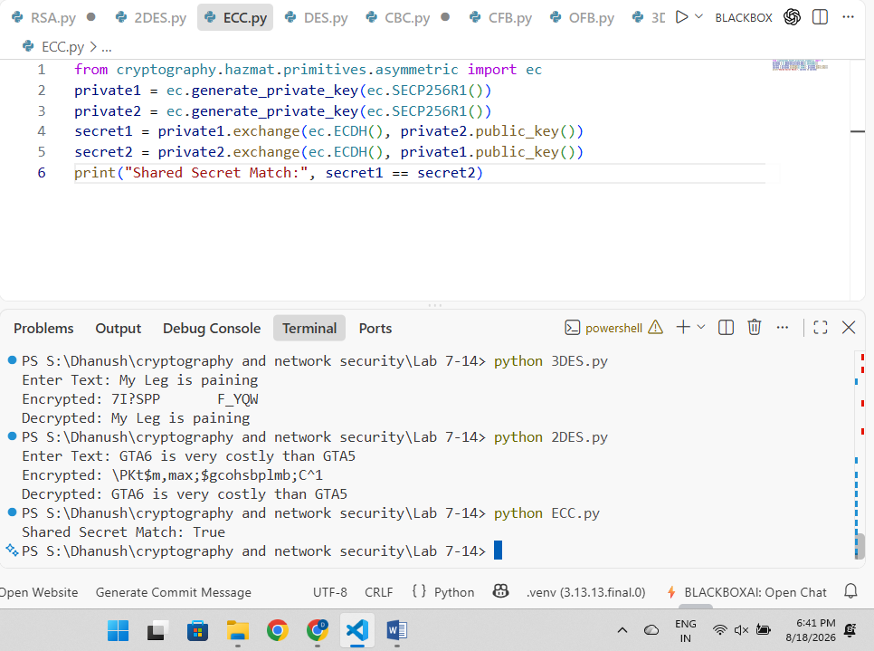

RESULT
Thus, ECC using ECDH was implemented successfully and the shared secret was generated.

EX.NO: 9 – IMPLEMENTATION OF DIFFIE–HELLMAN

AIM
To implement the Diffie-Hellman key exchange algorithm.

ALGORITHM
- Select prime number p and generator g.
- Generate private keys.
- Compute public keys.
- Exchange public keys.
- Generate shared secret key.
- Verify both keys are equal.

PYTHON PROGRAM
p = 23
g = 5

a = 6
b = 15

A = (g ** a) % p
B = (g ** b) % p

key1 = (B ** a) % p
key2 = (A ** b) % p

print("Alice Key:", key1)
print("Bob Key:", key2)

SAMPLE OUTPUT
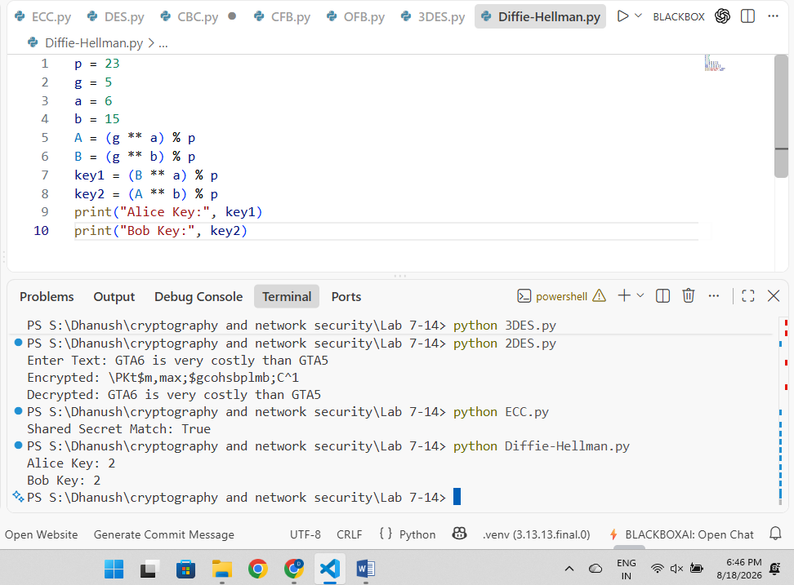

RESULT
Thus, the Diffie-Hellman key exchange algorithm was implemented successfully.

EX.NO: 10 – IMPLEMENTATION OF DES

AIM
To implement Data Encryption Standard (DES) using Python.

ALGORITHM
- Read plaintext.
- Generate DES key.
- Encrypt plaintext.
- Display ciphertext.
- Decrypt ciphertext.
- Display original plaintext.

PYTHON PROGRAM
from Crypto.Cipher import DES
from Crypto.Util.Padding import pad, unpad

key = b"12345678"

text = input("Enter Text: ")

cipher = DES.new(key, DES.MODE_ECB)

encrypted = cipher.encrypt(pad(text.encode(), 8))
print("Encrypted:", encrypted.hex())

decrypted = unpad(cipher.decrypt(encrypted), 8)
print("Decrypted:", decrypted.decode())

SAMPLE OUTPUT

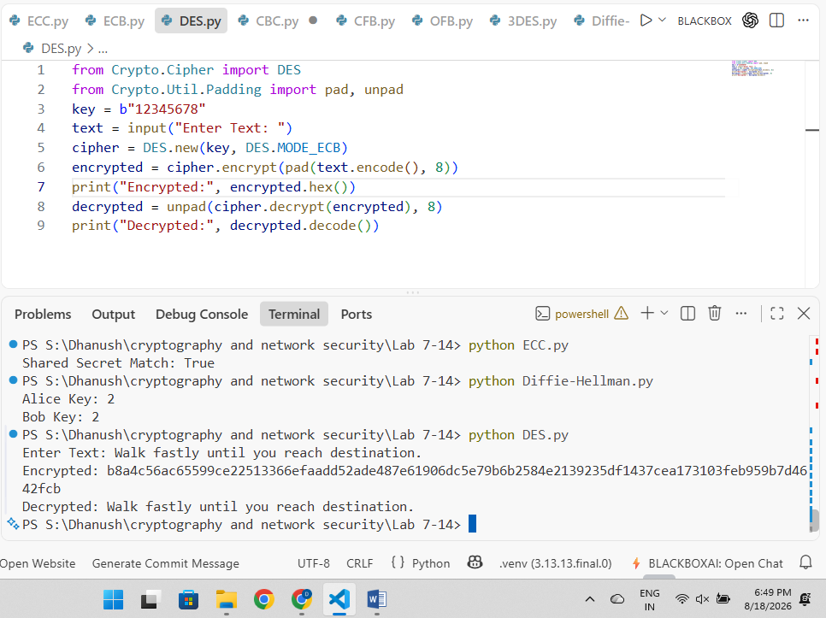

RESULT
Thus, the DES algorithm was implemented successfully.

EX.NO: 11 – IMPLEMENTATION OF BLOWFISH

AIM
To implement the Blowfish encryption and decryption algorithm using Python.

ALGORITHM
- Read plaintext and key.
- Create Blowfish cipher.
- Encrypt plaintext.
- Display ciphertext.
- Decrypt ciphertext.
- Display original plaintext.

PYTHON PROGRAM
from Crypto.Cipher import Blowfish
from Crypto.Util.Padding import pad, unpad

key = b"mysecretkey"

text = input("Enter Text: ")

cipher = Blowfish.new(key, Blowfish.MODE_ECB)

encrypted = cipher.encrypt(pad(text.encode(), 8))
print("Encrypted:", encrypted.hex())

decrypted = unpad(cipher.decrypt(encrypted), 8)
print("Decrypted:", decrypted.decode())

SAMPLE OUTPUT

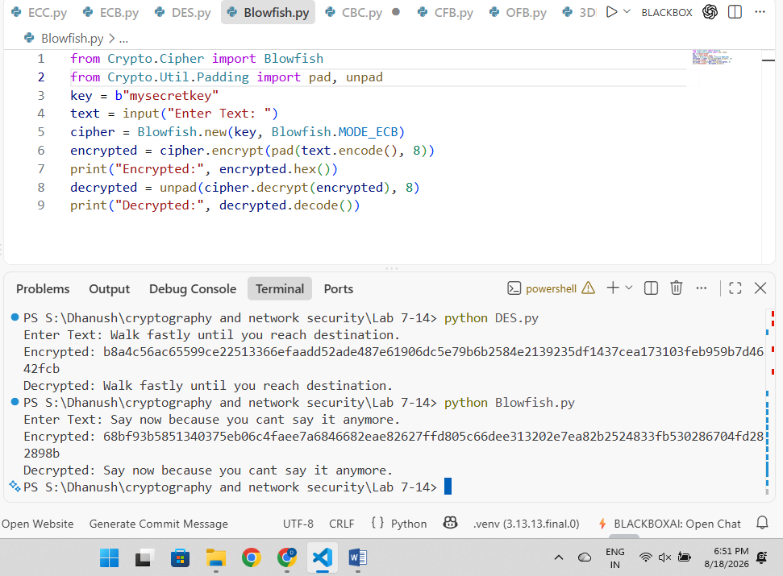

RESULT
Thus, the Blowfish encryption and decryption algorithm was implemented successfully.

